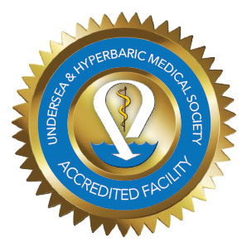 [Hospital Name] is pleased to announce [Hyperbaric Center Name] has received accreditation from the Undersea and Hyperbaric Medical Society (UHMS). UHMS accreditation means our facility has met or exceeded the highest standards of care and patient safety through rigorous evaluation of our operations, including equipment, staff and training to ensure that the utmost quality is maintained within the specialty of undersea and hyperbaric medicine.
Hyperbaric oxygen therapy involves the use of medical oxygen administered in a pressure chamber at levels higher than atmospheric pressure. This pressure helps oxygen dissolve more rapidly into the blood, advancing its absorption into damaged tissues to promote healing of wounds, serious infections, pressure-related scuba diving injuries, arterial gas embolism and other illnesses. A well-maintained chamber and trained support staff are essential in the daily operation of this important treatment adjunct.
Participating in the UHMS accreditation program is voluntary and takes months of preparation. Our team of physicians, nurses, technicians and management worked together prior to the accreditation survey to ensure compliance with UHMS-related standards of practice and safety measures. The survey team who visited our facility consisted of a physician, nurse and technician, all of whom specialize in hyperbaric oxygen therapy. Although their role included detailed queries, they came as colleagues in a specialty committed to success in achieving the highest standards in quality of care and safety for patients. The UHMS and its accredited facilities share the vision of helping facilities succeed in the field of hyperbaric medicine.
[ Insert Staff Photo ]
This accreditation demonstrates [Hospital Name] commitment to providing the highest quality of patient care at [Hyperbaric Center Name]. We are proud of our team members for achieving this significant milestone and of their commitment to their patients!
Add information here about your facility and brief description of services you provide.
Include quotes from your staff about what UHMS accreditation means to them and what it means to your organization.
Add photos of your hyperbaric center.
Include your website and phone numbers.
For more information about the UHMS and why accreditation is important visit uhms.org.

